Advance querying concepts

1-5-23

Q. query to find the name of employee from same department.

CREATE TABLE EMPLOYEEINFO(

EMP_ID INT PRIMARY KEY,

EMPLOYEE_NAME VARCHAR(100),

DEPARTMENT VARCHAR(100))

INSERT INTO EMPLOYEEINFO (EMP_ID, EMPLOYEE_NAME, DEPARTMENT)

VALUES (1,'Niranjan','HR'),(2,'Mayank','HR'),(3,'Ram','IT'),(4,'Shyam','MIS');

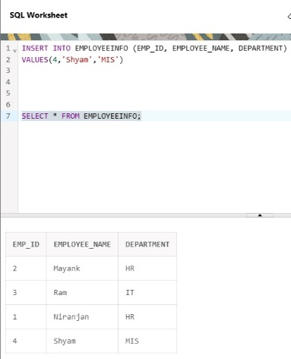

SELECT E.EMP_ID, E.EMPLOYEE_NAME, E.DEPARTMENT

FROM EMPLOYEEINFO E, EMPLOYEEINFO E1

WHERE E.DEPARTMENT =E1.DEPARTMENT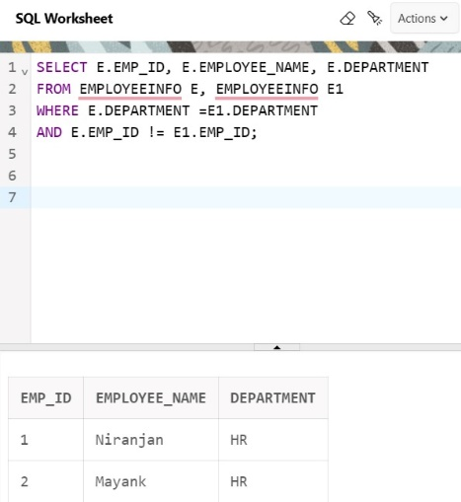 AND E.EMP_ID != E1.EMP_ID;